# **Identification of Safe Navigation Routes on the Moon Using Chandrayaan-3 Images**

**Major Project I Report**

Submitted in partial fulfillment of the requirements for the degree of

**Bachelor of Engineering (Computer Engineering)**

by:

|  |  |
| --- | --- |
| 1. **Aniket Dinde** | **ID no:- TU3F2122173** |
| 1. **Rushikesh Jadhav** | **ID no:- TU3F2122167** |
| 1. **Saurav Shinde** | **ID no:- TU3F2122180** |
| 1. **Jeevan Choudhary** | **ID no:- TU3F2122186** |

**Under the Guidance of**

**Dr. Vishwajit Gaikwad**



**Department of Computer Engineering**

**TERNA ENGINEERING COLLEGE**

Nerul (W), Navi Mumbai 400706

**(University of Mumbai)**

(2024-2025)



**TERNA ENGINEERING COLLEGE, NERUL,**

**NAVI MUMBAI**

**Department of Computer Engineering**

Academic Year 2024-25

**CERTIFICATE**

This is to certify that the major project I entitles **“Identification of Safe Navigation Routes on the Moon Using Chandrayaan-3 Images”** is a Bonafide work of

1. **Aniket Dinde ID No: TU3F2122173**
2. **Rushikesh Jadhav ID No: TU3F2122167**
3. **Saurav Shinde ID No: TU3F2122180**
4. **Jeevan Choudhary ID No: TU3F2122186**

submitted to the University of Mumbai in partial fulfillment of the requirement for the award of the Bachelor of Engineering (Computer Engineering).

**Guide Head of Department Principal**

**Approval Sheet**

**Project Report Approval**

This Major Project Report – an entitled “**Identification of Safe Navigation Routes on the Moon Using Chandrayaan-3 Images**” by following students is approved for the degree of ***B.E. in "Computer Engineering"***.

**Submitted by:**

|  |  |
| --- | --- |
| 1. **Aniket Dinde** | **ID No: TU3F2122173** |
| 1. **Rushikesh Jadhav** | **ID No: TU3F2122167** |
| 1. **Saurav Shinde** | **ID No: TU3F2122180** |
| 1. **Jeevan Choudhary** | **ID No: TU3F2122186** |

Examiners Name & Signature:

1.---------------------------------------------------------

2.----------------------------------------------------------

Date: ---------------------------------

Place: ---------------------------------

**Declaration**

We declare that this written submission represents our ideas in our own words and where others' ideas or words have been included, we have adequately cited and referenced the original sources. We also declare that we have adhered to all principles of academic honesty and integrity and have not misrepresented or fabricated or falsified any idea/data/fact/source in our submission. We understand that any violation of the above will be cause for disciplinary action by the Institute and can also evoke penal action from the sources which have thus not been properly cited or from whom proper permission has not been taken when needed.

|  |  |  |
| --- | --- | --- |
| **Aniket Dinde** | **ID No: TU3F2122173** | --------------------------- |
| **Rushikesh Jadhav** | **ID No: TU3F2122167** | --------------------------- |
| **Saurav Shinde** | **ID No: TU3F2122180** | --------------------------- |
| **Jeevan Choudhary** | **ID No: TU3F2122186** | --------------------------- |

Date: _____________________

Place: _____________________

**Acknowledgement**

We would like to express our sincere gratitude towards our guide **Dr. Vishwajit Gaikwad**, Project Coordinators **Dr. Mohini Misale** for their help, guidance and encouragement, they provided during the project development. This work would have not been possible without their valuable time, patience and motivation. We thank them for making my stint thoroughly pleasant and enriching. It was great learning and an honor being their student.

We are deeply thankful to **Dr. Kishor Sakure (H.O.D Computer Department)** and entire team in the Computer Department. They supported us with scientific guidance, advice and encouragement, they were always helpful and enthusiastic and this inspired us in our work.

We take the privilege to express our sincere thanks to **Dr. L. K. Ragha**our Principal for providing the encouragement and much support throughout our work.

|  |  |
| --- | --- |
| **Aniket Dinde** | **ID No: TU3F2122173** |
| **Rushikesh Jadhav** | **ID No: TU3F2122167** |
| **Saurav Shinde** | **ID No: TU3F2122180** |
| **Jeevan Choudhary** | **ID No: TU3F2122186** |

Date: _____________________

Place: _____________________

## **INDEX**

|  |  |  |
| --- | --- | --- |
| **TABLE OF CONTENTS** | | |
| **Sr. No.** | **Title** | **Page No.** |
|  | Abstract | 7 |
|  | List of Figures | 8 |
|  | List of Tables | 8 |
| Chapter 1 | Introduction | 9 |
| Chapter 2 | Problem Statement  3.1 Problem Statement  3.2 Objectives  3.3 Features  3.4 Specification of System | 10 |
| Chapter 3 | Literature Review | 12 |
| Chapter 4 | Software Requirement Specifications | 16 |
| Chapter 5 | Design & Implementation  4.1 Design Phase  4.2 Implementation Phase | 18 |
| Chapter 6 | Methodology | 25 |
| Chapter 7 | Future Scope | 27 |
|  | Reference | 29 |

## **Abstract**

The exploration of the lunar surface presents significant challenges due to its complex and varied terrain, which includes craters, boulders, and other obstacles. This project aims to address these challenges by developing an advanced system that leverages deep learning and reinforcement learning (RL) techniques to automate the detection of lunar surface features and optimize rover path planning. Utilizing high-resolution Orbiter High Resolution Camera (OHRC) imagery, convolutional neural networks (CNNs) are employed to accurately identify and classify obstacles such as craters and boulders, regardless of their size or shape. These CNN-based models will enable real-time, detailed recognition of terrain features, providing valuable selenographic data, including the positions and dimensions of detected obstacles.

In parallel, a reinforcement learning framework will be integrated into the system to optimize the rover's navigation across the lunar surface. By continuously learning and adapting to the environment, the RL model will plan safe and efficient traversal routes that avoid identified obstacles while prioritizing scientific exploration objectives. This method ensures that the rover can autonomously navigate challenging terrains, improving both mission safety and the quality of scientific data collection.

The outcome of this project includes annotated maps of lunar surface features, optimal rover routes, and a robust framework that combines state-of-the-art AI techniques to enhance lunar exploration capabilities. By offering a sophisticated solution for obstacle detection and path planning, this system paves the way for more efficient, autonomous exploration of the Moon, contributing to future scientific missions and long-term lunar habitation efforts.

|  |  |  |
| --- | --- | --- |
| **Sr no.** | **List of figures** | **Page no.** |
| Fig 5.1.1 | DFD Level 0 | 18 |
| Fig 5.1.2 | DFD Level 1 | 19 |
| Fig 5.1.3 | DFD Level 2 | 20 |
| Fig 5.1.4 | Sequence Diagram | 22 |
| Fig 5.2.1 | Flowchart | 23 |
| Fig 5.2.2 | Architecture Diagram | 24 |

|  |  |  |
| --- | --- | --- |
| **Sr no.** | **List of Tables** | **Page no.** |
| Table 3.1 | Literature Survey | 13-15 |

**Chapter 1**

**INTRODUCTION**

The exploration of the Moon's south pole has garnered significant attention due to its scientific and strategic potential. This region contains some of the most promising sites for future lunar exploration, offering insights into the Moon’s history and resources critical for sustaining future missions. The presence of permanently shadowed craters that may contain water ice presents a unique opportunity for research, as such resources could support human presence on the Moon. Additionally, regions near the lunar poles experience extended periods of sunlight, making them ideal for solar-powered missions, especially those involving long-term exploration by robotic systems like rovers.

India's Chandrayaan-2 mission, launched by the Indian Space Research Organisation (ISRO), has contributed immensely to our understanding of the Moon’s south pole. The mission has provided high-resolution optical and topographic data of this region, enabling detailed mapping and analysis of the lunar surface. This data is invaluable for planning rover missions, as it helps identify both obstacles, such as craters and boulders, and areas of scientific interest. The combination of these factors makes the south pole an ideal target for future exploration missions focused on resource extraction, planetary science, and the potential for human habitation.

To accomplish this, the project integrates artificial intelligence techniques, specifically deep learning and reinforcement learning, for obstacle detection and path planning.

High-resolution images from the Chandrayaan-2 mission will be analyzed using Convolutional Neural Networks (CNNs) to identify and classify obstacles based on their

shapes and sizes. This information will be used to develop an annotated map of the region, including craters, boulders, and other surface features. Additionally, reinforcement learning (RL) algorithms will be applied to optimize the rover's navigation path, balancing the need to avoid obstacles while maximizing scientific exploration and sunlight exposure.

The final outcome of this project is an annotated map that details the rover’s proposed track, highlighting key stops and significant surface features. This map will be accompanied by a comprehensive rationale explaining the scientific importance of each stop, as well as the navigational decisions made to ensure the rover's safe traversal.

**Chapter 2**

**Problem Statement**

**2.1 Problem statement:-**

Exploration of the Moon’s south pole presents unique challenges due to its harsh terrain, extreme lighting conditions, and the presence of permanently shadowed regions. The Chandrayaan missions have provided valuable optical and topographic data of this region, particularly near the coordinates 85.28° S, 31.20° E, which have been identified as a potential landing site for future missions. To ensure the success of rover-based exploration in this area, it is essential to develop a precise navigation route that enables safe traversal while maximizing scientific exploration opportunities.

The objective of this project is to design a 100-meter-long navigation route on the lunar surface, starting from the designated landing site. This route must avoid obstacles such as craters, boulders, and steep slopes, while allowing the rover to collect scientific data at key stops. The path can be designed to either remain within continuously sunlit areas or to traverse between shadowed and sunlit regions, depending on the desired scientific objectives and energy requirements of the rover.

Key considerations include:

* **Obstacle Avoidance**: Utilizing optical and topographic data from the Chandrayaan missions to identify and avoid hazards along the rover’s path, such as large craters, boulders, and steep inclines.
* **Lighting Conditions**: Determining whether the rover should remain in sunlit regions for continuous power generation via solar panels or explore both sunlit and shadowed areas to gather diverse scientific data.
* **Scientific Stops**: Designing the route to include stops where the rover’s instruments can conduct in-depth analysis of the lunar surface, focusing on areas of interest identified through data analysis.
* **Path Planning**: Justifying the selected direction of the route based on terrain analysis, scientific value, and safety considerations for the rover.

The development of a safe and scientifically valuable route will contribute to the success of future lunar exploration missions, enhancing our understanding of the Moon's south pole and its potential for future human habitation.

**2.2 Objectives**

The project aims to develop an advanced navigation system for lunar rovers using data from the Chandrayaan missions. The specific objectives are:

1. **Crater and Obstacle Detection**Use U-Net architecture to detect craters, boulders, and obstacles from lunar surface images.
2. **Adaptive Path Planning**Implement reinforcement learning to optimize rover navigation, ensuring safe and efficient traversal.
3. **Scientific Exploration Points**Identify and prioritize scientifically valuable locations along the route for data collection.
4. **Route Validation via Simulation**Validate the proposed path using simulations that account for lunar terrain and rover capabilities.
5. **Annotated Route Map**Provide a detailed, annotated map marking the landing site, path, and exploration points.
6. **Hardware Optimization**Ensure models are optimized for the rover’s computational and power constraints.
7. **Comprehensive Documentation**Deliver thorough documentation to assist future mission planners with path planning and obstacle avoidance.

**Chapter 3**

**Literature Review**

The development of lunar and planetary exploration technologies has significantly advanced in recent years, focusing on establishing sustainable operations, improving navigation systems, and enhancing crater detection capabilities. Marov and Slyuta (2021) emphasize the strategic potential of establishing lunar bases for space exploration and the utilization of lunar resources for both in-situ operations and potential Earth-based applications. They also highlight critical challenges, such as radiation protection and reliable life support systems, which remain areas needing innovative solutions (Marov & Slyuta, 2021) [1].

In terms of navigation, Abcouwer et al. (2021) present a machine learning-based path planning system that successfully integrates heuristics with the existing ENav system to enhance rover navigation efficiency on planetary surfaces. Their findings show improvements in computational efficiency and safer path selection but also identify a need for further research into better heuristic models and real-time adaptability for more complex, dynamic environments (Abcouwer et al., 2021) [2]. Jia et al. (2020) further contribute to lunar surface analysis by introducing an enhanced U-Net model for automated crater detection, achieving superior accuracy and faster convergence. However, the need for better handling of complex crater shapes and real-time application remains a research gap (Jia et al., 2020) [3].

Wang and Wu (2019) address crater detection from both imagery and digital elevation models (DEM), achieving improved accuracy through active machine learning techniques. Their method, validated across lunar and Martian datasets, provides versatility but leaves room for improvements in handling highly complex terrain and scaling to larger datasets (Wang & Wu, 2019) [4]. Lastly, Brockers et al. (2021) present a system for autonomous safe landing site detection on Mars, demonstrating success in real-time processing and 3D terrain perception. Their work highlights the need for further optimization to enhance adaptability in rapidly changing or highly complex environments (Brockers et al., 2021) [5].

Other recent contributions include a deep learning-based crater detector for spacecraft navigation (Del Prete et al., 2022) [6], the use of deep reinforcement learning for large-scale autonomous navigation of lunar rovers (Hu et al., 2021) [7], and an analysis of feature detectors applied to lunar crater detection (Kuzmenko & Ostroumov, 2021) [8].

|  |  |  |  |
| --- | --- | --- | --- |
| **Author(Year)** | **Title of Paper** | **Findings** | **Research Gap** |
| Mikhail Ya. Marov, Evgeny N. Slyuta (2021) [1] | Early steps toward the lunar base deployment | 1.Establishing a lunar base opens **strategic opportunities for Earth control and space exploration.**  ​  2.Utilizing lunar resources offers prospects for **supporting lunar operations** and potential Earth delivery. ​  3.The Moon's far side presents **new possibilities for radio astronomy** due to its shielding from terrestrial radio noise.  4.​**Safety issues, including radiation protection** and reliable life support systems, are critical for lunar exploration​​. | **1.Resource Utilization**: Need for effective methods to extract and process lunar resources for sustained operations.  **2.Life Support Systems**: Lack of innovative solutions for long-term radiation protection and environmental control.  **3.Radio Astronomy**: Insufficient studies on optimal locations and technologies for lunar far-side radio astronomy.  **4.Operational Strategies**: Need for strategic frameworks for coordinating logistics and scientific missions on the Moon.  **5.Earth Integration**: Exploration of the impact of lunar operations on existing Earth-based systems is lacking. |
| Neil Abcouwer; Shreyansh Daftry; Tyler del Sesto; Olivier Toupet; Masahiro Ono; Siddarth Venkatraman; Ravi Lanka; Jialin Song;Yisong Yue (2021) [2] | Machine Learning Based Path Planning for Improved Rover Navigation | **1.Reduced ACE Evaluations:** Heuristics significantly lowered the number of ACE checks needed. ​  **2.Increased Computational Efficiency:** Decreased computational load by pre-filtering unsafe paths.  **3.Better Path Efficiency:** Improved selection of safer, more efficient paths. ​  **4.Successful Integration:** Heuristics integrated well with the existing ENav system. ​  **5.Experimental Validation:** Experiments confirmed reduced computation time and improved navigation performance. ​  **6.Effective Machine Learning:** The neural network accurately predicted ACE values, aiding early path selection. | **1.Heuristic Limits**: Need for better heuristics in complex, dynamic environments.  **2.Real-time Adaptation**: Insufficient focus on real-time model adaptability.  **3.Scalability**: Limited scalability for larger, diverse terrains.  **4.ML Generalization**: Research needed for model generalization across planetary surfaces.  **5.ACE Precision**: Scope for improving ACE prediction accuracy. |
| Yutong Jia; Gang Wan; Lei Liu; Yitian Wu; Chenyang Zhang(2020) [3] | Automated Detection of Lunar Craters Using Deep Learning | **1.Higher Accuracy:** The improved U-Net model achieved 93.4% accuracy, compared to 89.4% for the traditional U-Net.  ​  **2. Better Overlapping Crater Detection:** It effectively identifies overlapping and intersecting craters. ​  **3. Effective Post-Processing:** Improved post-processing techniques reduce false negatives.  ​  **4. Faster Convergence:** The model converges more quickly than the traditional U-Net. | **1.Crater Complexity**: Further work is needed to improve detection of highly irregular or eroded craters.  **2.Generalization**: Limited focus on the model’s ability to generalize across different lunar regions.  **3.Real-time Application**: Lack of exploration in deploying the model for real-time crater detection in rover operations.  **4.Post-Processing**: Opportunities exist to refine post-processing techniques for reducing false positives. |
| Yiran Wang; Bo Wu(2019)[4] | Active Machine Learning Approach for Crater Detection From Planetary Imagery and Digital Elevation Models | **1. Improved Accuracy:** Enhanced crater detection accuracy by combining image and DEM data. ​  **2.Efficiency:** Faster detection with a cascade structure and reduced manual labeling through active learning. ​  **3.Validation Success:** Successfully validated on lunar and Martian datasets, showing superior performance.  **4.Versatility:** Adaptable to different planetary surfaces, proving robustness and broad applicability. | **1.Complex Terrain Handling**: More research needed to handle highly complex or ambiguous terrain features.  **2.Scalability**: Limited exploration of scaling the method to larger datasets or real-time applications.  **3.Model Generalization**: Further work required to improve model generalization across diverse planetary terrains.  **4.Active Learning Refinement**: Opportunities to optimize active learning for even greater reduction in manual labeling. |
| Roland Brockers; Jeff Delaune; Pedro Proença; Pascal Schoppmann; Matthias Domnik; Gerik Kubiak; Theodore Tzanetos (2021) [5] | Autonomous Safe Landing Site Detection for a Future Mars Science Helicopter | **1. Autonomous Landing:** Successfully developed an autonomous system for detecting safe landing sites on Mars. ​  **2. 3D Terrain Perception:** Implemented a robust method combining state estimation and 3D reconstruction using VIO and laser altimetry. ​  **3. Multi-Resolution Mapping:** Created an efficient multi-resolution elevation map for dynamic terrain assessment. ​  **4. Safe Landing Criteria:** Established reliable criteria for safe landing sites, including slope, roughness, and confidence in terrain data. ​  **5. Validation:** Demonstrated effectiveness through simulations and experimental flights, confirming the system's accuracy and reliability. ​  **6. Computational Efficiency:** Achieved near real-time processing suitable for embedded systems on Mars missions. ​  **7. Future Potential:** Highlighted the system's potential to enhance autonomous exploration and landing on Mars and other planetary bodies. | **1.Complex Terrain Handling**: Further research needed for improving performance in highly complex or dynamic terrains.  **2.Real-time Adaptability**: Limited exploration of real-time adaptability in rapidly changing environments.  **3.Generalization**: Need for better generalization across different planetary surfaces beyond Mars.  **4.Computational Constraints**: Opportunities to further optimize computational efficiency for extended missions |

**Table 3.1** Literature Survey

**Chapter 4**

**Software Requirements Specification**

**4.1 External Interface Requirements**

**4.1.1 User Interfaces**

The user interface for system shall be compatible to any type of web browser such as

Mozilla ,Firefox, Google Chrome, and Internet Explorer.

**4.1.2 Software Interfaces**

Google Colab - Python 3.9.2

Operating System - Windows(64-bit) macOS 10.12.6

**4.1.3 Hardware Interfaces**

Processor -2.10GHz or faster

RAM - Minimum 2GB

Memory - Minimum 200MB

**4.2 Functional Requirements:​ ​**

**4.2.1 Data Processing:​**

Ability to ingest and process datasets from Chandrayaan-2, including TMC, DTM, DEM, and OHRC images.​

**4.2.2 Crater and Boulder Detection:​**

Implement U-net architecture to accurately detect and map craters, boulders, and other potential hazards on the lunar surface.​

**4.2.3 Path Planning:​**

Apply reinforcement learning algorithms (e.g., A3C) to plan safe and efficient navigation routes, avoiding obstacles and optimizing for scientific value.​

**4.2.4 Scientific Mapping:​**

Integrate Imaging Infra-Red Spectrometer (IIRS) data to identify and map scientifically valuable areas for exploration.​

**4.2.5 Simulation Validation:​**

Validate the proposed navigation paths through simulation, ensuring that the routes are feasible and meet mission objectives.

**4.3 Non-Functional Requirements:​ ​**

**4.3.1 Computational Efficiency:​**

Ensure that the system processes data and generates navigation routes efficiently, enabling near real-time decision-making.​

**4.3.2 Accuracy:​**

Maintain high accuracy in detecting obstacles and mapping paths to ensure the safety of the lunar rover.​

**4.3.3 Scalability:**

**​**Design the system to be scalable, allowing adaptation to different lunar regions and potential future missions.

**4.4 Performance Requirements**

**4.4.1 Response Time**

Acceptable response times for various system operations, such as data input, model

training, and prediction generation.

**4.4.2 Scalability**

System should scale with increased data volume or user load.

**4.4.3 Prediction Throughput**

Predictions can be processed quickly, especially for real-time monitoring.

**4.4.4 Security Performance**

Performance requirements for security measures, such as encryption and access control.

**4.4.5 Data Processing Speed**

Data should be processed, including data cleaning, feature extraction, and preprocessing steps. Optimize data processing algorithms for efficiency.

**4.5 Security requirements**

**4.5.1 Data Encryption**

Ensure that all sensitive data, including historical water quality data and model parameters, are encrypted both in transit and at rest to prevent unauthorized access.

**4.5.2 Access Control**

Implement strict access controls to restrict access to the prediction system based on user roles and responsibilities. Only authorized personnel should be able to interact with and modify the system.

**4.5.3 Authentication and Authorization**

Require strong authentication mechanisms, such as multi-factor authentication, to verify the identity of users. Authorization mechanisms should be in place to define what actions users are allowed to perform within the system.

**4.5.4 Data Integrity**

Implement measures to ensure the integrity of data, such as checksums and data validation, to detect and prevent data tampering or corruption.

**Chapter 5**

**Design and Implementation**

**5.1 Design Phase:**

* **5.1.1 Data Flow Diagram (Level 0)**

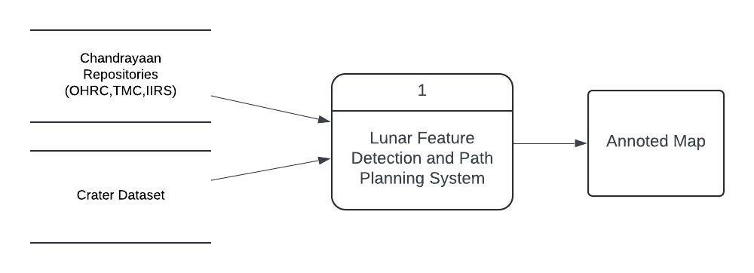

DFD Level 0

**Concise explanation of the Level 0 DFD:**

1. **System:** The Lunar Feature Detection and Path Planning System processes data.
2. **Inputs:**
   * Chandrayaan Repositories (OHRC, TMC, IIRS) provide lunar surface data.
   * Crater Dataset supplies crater-specific information.
3. **Process:** The system detects lunar features and plans a safe rover path.
4. **Output:** An annotated map with identified features and the rover's path.

* **5.1.2 Data Flow Diagram (Level 1)**

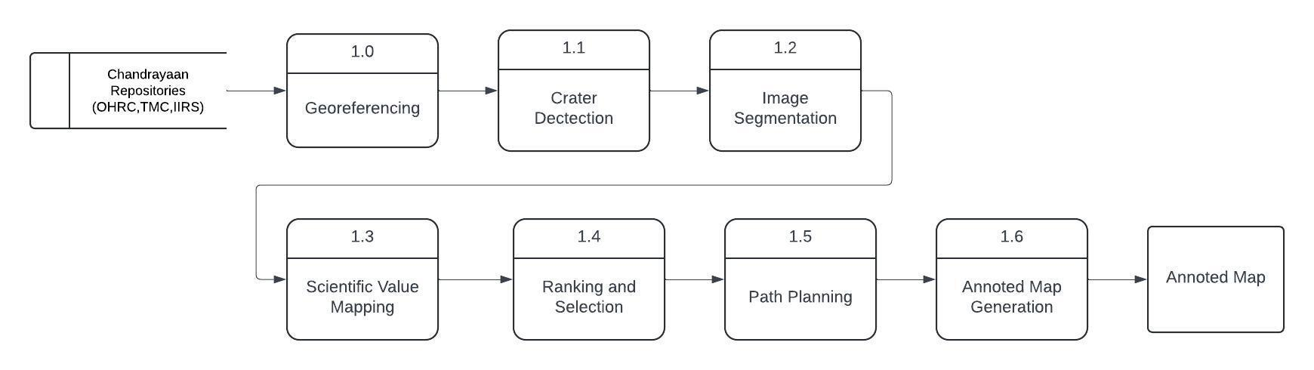

DFD Level 1

**Analysis of the Level 1 Data Flow Diagram:**

1. **Input:** Data from Chandrayaan Repositories (OHRC, TMC, IIRS) is used throughout the process.
2. **Processes:**
   * 1.0 Georeferencing: Aligns the Chandrayaan data with a known coordinate system.
   * 1.1 Crater Detection: Identifies craters using the processed data.
   * 1.2 Image Segmentation: Separates the lunar surface into distinct regions for analysis.
   * 1.3 Scientific Value Mapping: Assigns scientific significance to different regions or features.
   * 1.4 Ranking and Selection: Prioritizes key areas based on scientific value and rover accessibility.
   * 1.5 Path Planning: Develops a safe and optimal path for the rover, avoiding obstacles.
   * 1.6 Annotated Map Generation: Produces the final annotated map, which includes paths and significant stops.
3. **Output:** The final annotated map with detected features and the planned rover path.

* **5.1.3 Data Flow Diagram (Level 2)**

DFD Level 2

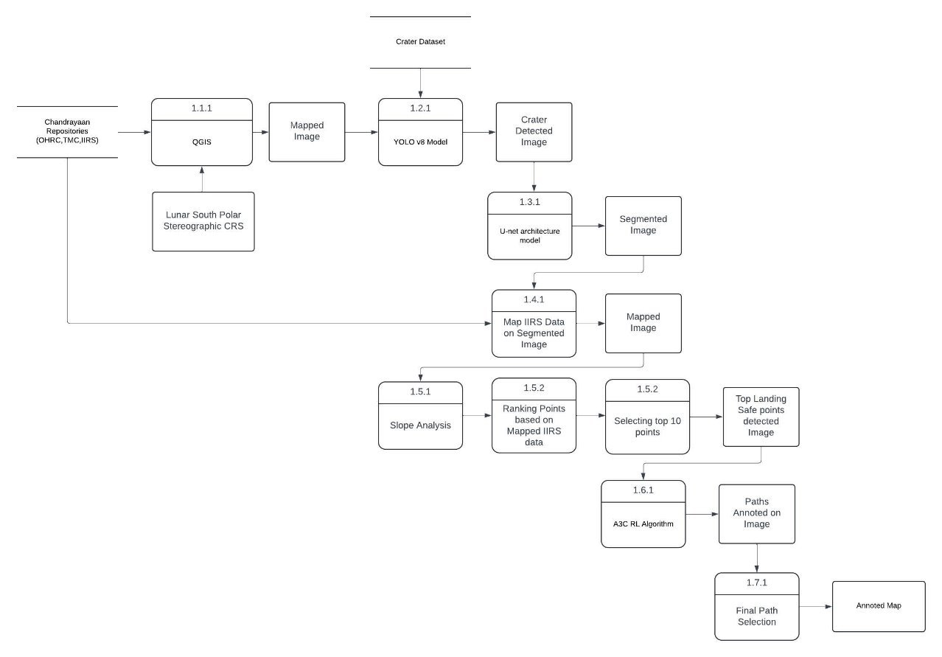

**Analysis of the Level 2 DFD:**

1. **Inputs:**
   * Chandrayaan Repositories (OHRC, TMC, IIRS) provide data for georeferencing.
   * The Crater Dataset is processed using the YOLO v8 Model for crater detection.
2. **Processes:**
   * Georeferencing: Aligns lunar data with geographic coordinates using QGIS.
   * Crater Detection: Identifies craters, creating a crater detected image.
   * Image Segmentation: Uses a U-Net architecture model to segment the image into distinct regions for feature identification.
   * Scientific Data Mapping: Maps scientific values onto the segmented image.
   * Slope Analysis: Evaluates slopes to aid safe rover navigation.
   * Point Ranking and Selection: Ranks points based on scientific significance and slope analysis, selecting top landing safe points.
3. **Path Planning:**
   * A3C RL Algorithm: Plans the rover's path, considering detected features and obstacles.
   * The path is annotated on the image, and final path selection is made.
4. **Output:**
   * The process produces an annotated map showing the rover’s path, scientifically significant stops, and safe landing points.

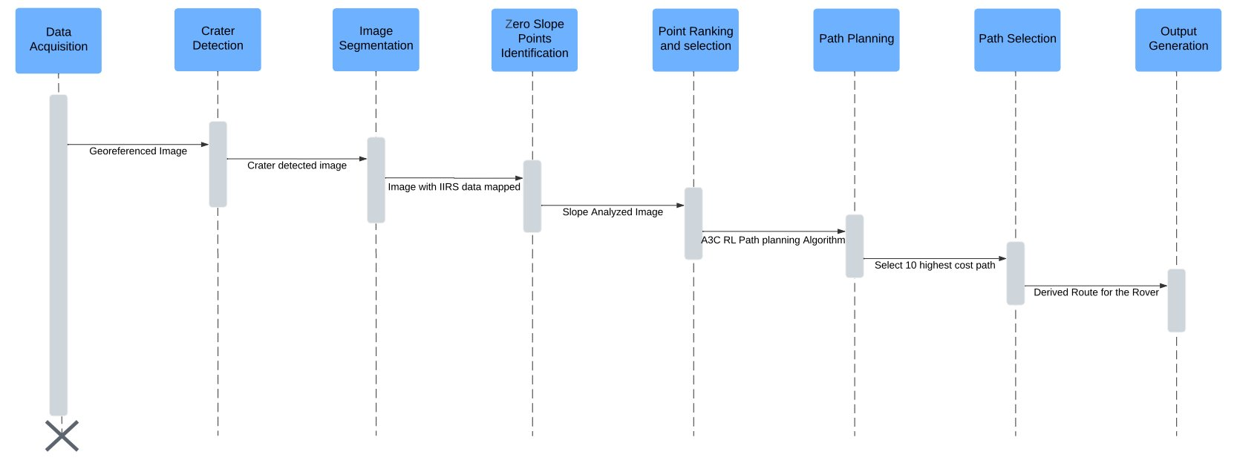**5.1.4 Sequence Diagram**

This diagram illustrates a step-by-step process for finding a safe navigation route for a rover on the Moon. The workflow involves the following stages:

1. **Data Acquisition:** Collecting georeferenced lunar images for analysis.
2. **Crater Detection:** Identifying craters in the images to avoid potential hazards.
3. **Image Segmentation:** Mapping relevant scientific data from the Imaging Infra-Red Spectrometer (IIRS) onto the images.
4. **Zero Slope Points Identification:** Detecting flat terrain areas by analyzing the slope of the surface.
5. **Point Ranking and Selection:** Ranking the identified points based on scientific significance and selecting suitable locations for navigation.
6. **Path Planning:** Using an A3C Reinforcement Learning (RL) algorithm to plan the optimal path.
7. **Path Selection:** Choosing the top 10 paths with the highest scientific value or cost for the rover.
8. **Output Generation:** Producing a derived navigation route for the rover based on the selected paths.

This workflow aims to ensure the rover's safe traversal while optimizing for scientific exploration.

**5.2 Implementation Phase:**

* **5.2.1 Flowchart**

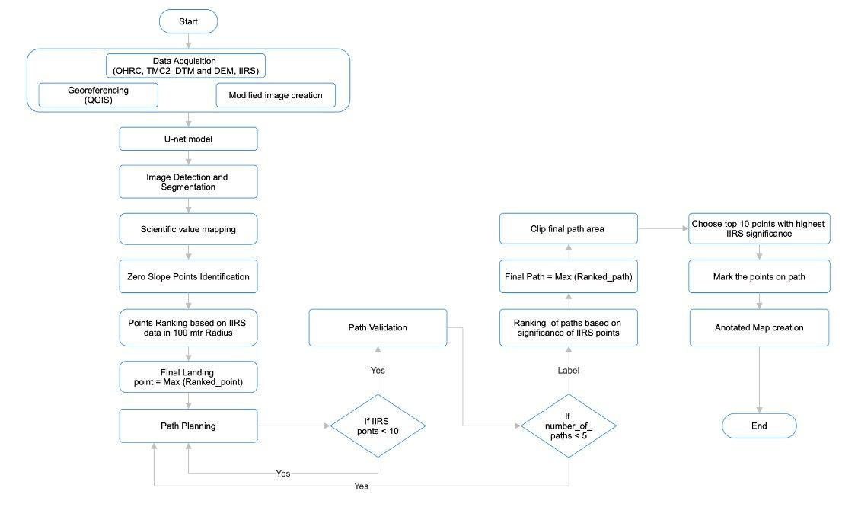

* **Data Retrieval:** Data from OHRC, TMC2, and IIRS is collected.
* **Feature Detection:** QGIS and U-Net Model perform georeferencing and image segmentation.
* **Scientific Value Mapping:** Slope analysis overlays IIRS data to identify valuable areas.
* **Navigation Points:** Key navigation points for landing are identified.
* **Point Ranking:** Landing points are ranked and the final site is selected.
* **Path Planning:** A3C RL algorithm finds optimal paths, assigning costs to each.
* **Path Selection:** Highest cost path with 10 stops is chosen.
* **Output Generation:** An annotated map is created with the final path.
* **5.2.2 Architecture Diagram**

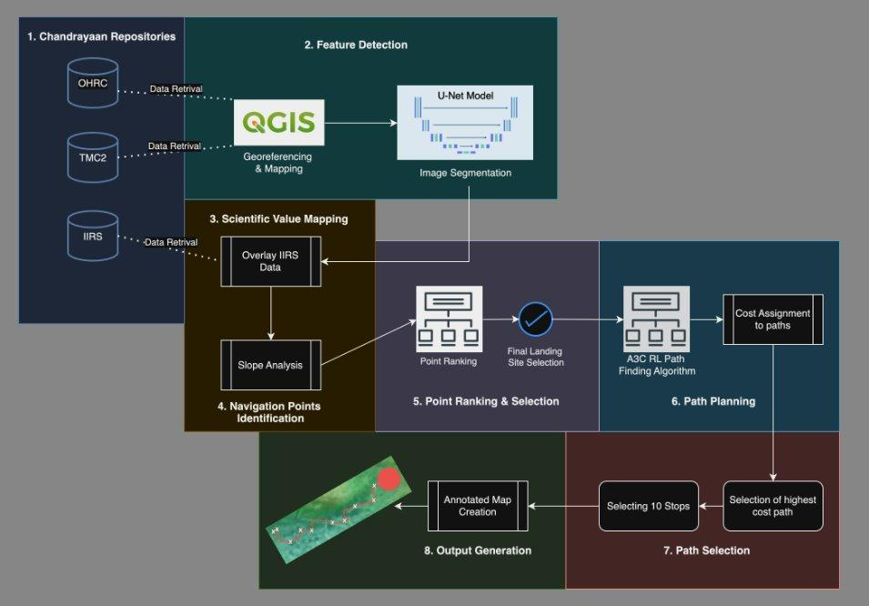

* **Data Acquisition:** Collect data from OHRC, TMC2, and IIRS.
* **Georeferencing:** Use QGIS for georeferencing and creating modified images.
* **Image Segmentation:** Apply U-Net model for feature detection.
* **Scientific Value Mapping:** Analyze and identify zero slope points.
* **Point Ranking:** Rank landing points using IIRS data within 100m radius.
* **Landing Site:** Select the final landing point based on ranking.
* **Path Planning:** Plan path, then validate based on IIRS points.
* **Final Path Selection:** Rank paths by IIRS significance and select top 10 points.
* **Annotated Map:** Create a map marking the final selected path.

**Chapter 6**

**Methodology**

This section outlines the systematic approach undertaken in this project to utilize data from various Chandrayaan repositories for georeferencing, feature detection, and path planning. The methodology is structured into distinct phases as detailed below:

### 1. Data Acquisition

Data was sourced from three key repositories:

* **OHRC (Optical High-Resolution Camera):** High-resolution imagery was obtained to analyze lunar surface features.
* **TMC2 (Terrain Mapping Camera 2):** Terrain and surface data were collected for comprehensive surface analysis.
* **IIRS (Indian Institute of Remote Sensing):** Geospatial datasets relevant to the project were accessed.

#### Georeferencing All acquired datasets were georeferenced using QGIS, ensuring spatial alignment and integration of different data layers, which is critical for accurate analysis.

Lunar surface images were sourced from publicly available web-based datasets, ensuring comprehensive coverage of the area of interest for crater detection.

**2.** **Image Conversion**:

* The obtained images were initially in the *.img format, which is often used for satellite imagery. To make them compatible with a variety of geospatial tools, the images were converted to the widely supported GeoTIFF (*.tif) format using **GDAL (Geospatial Data Abstraction Library)**.

### 3. Image Processing

* After conversion, the images were imported into **OpenCV**, a powerful library for image processing.
* The large images were split into smaller tiles with a resolution of 1000x1000 pixels. This step was taken to ensure efficient handling of data during further processing and to maintain an optimal balance between computational resources and detection accuracy.

**4. Transfer Learning and Model Application**:

* We employed **transfer learning** with the **YOLOv8 (You Only Look Once)** object detection model, which is well-suited for tasks involving object localization and classification.
* The pre-trained model was fine-tuned using data from the **Chandrayaan-3 dataset**, which provided a rich set of lunar surface images for crater detection. This allowed the model to adapt specifically to the characteristics of lunar imagery, enhancing its performance in detecting craters.

**5. Crater Detection and Confidence Scoring**:

* The YOLOv8-based model was then applied to the processed image tiles to detect craters.
* Each detected crater was annotated with a **confidence score**, reflecting the model’s certainty in identifying the crater. This ensures that the results can be assessed both quantitatively (location and size of craters) and qualitatively (confidence level of detection).

**Chapter 7**

**Conclusion and Future Scope**

To effectively address the spatial resolution differences between the Chandrayaan-2 Terrain Mapping Camera (TMC) and the Lunar Reconnaissance Orbiter Wide Angle Camera (LRO WAC) mosaic, advanced techniques and tools were applied. QGIS and OpenCV were utilized for precise template matching, enabling accurate extraction of crater coordinates despite the resolution disparities. QGIS facilitated the management and alignment of spatial data, while OpenCV implemented advanced template matching algorithms, ensuring that crater locations were identified with high accuracy.

The accuracy of this method was validated by comparing the retrieved latitude and longitude of craters with their actual locations, achieving a high correlation value (≥0.70). This level of precision is essential for reliable geological and geophysical studies of the lunar surface, providing valuable data for future missions. By establishing accurate crater coordinates, the tool aids scientists in analyzing crater distribution and morphology, enhancing understanding of lunar geological history and impact processes.

This work significantly contributes to lunar exploration, supporting ongoing studies and establishing a foundation for automated crater identification and localization advancements. The methodologies and tools developed could be further enhanced through machine learning and advanced image processing techniques, paving the way for more efficient and precise planetary mapping. The success of this project underscores the importance of integrating geospatial tools and image processing libraries in planetary science, setting the stage for future developments in automated planetary exploration.

**FUTURE SCOPE**

* **Adaptation to Other Lunar Regions:** Extend the navigation system to various lunar terrains, enhancing exploration capabilities beyond the south pole.
* **Integration with New Datasets:** Incorporate data from upcoming missions, such as Chandrayaan-3, to improve obstacle detection and path optimization.
* **Real-time Processing:** Develop real-time navigation capabilities, allowing rovers to dynamically adapt to changing terrain conditions.
* **Collaboration with Autonomous Systems:** Integrate with existing autonomous navigation technologies for enhanced multi-rover missions and collaborative exploration.
* **Robustness in Diverse Conditions:** Ensure the system operates effectively under extreme lunar conditions, such as temperature fluctuations and dust storms.
* **Application to Other Celestial Bodies:** Adapt methodologies for navigation on Mars and other planetary bodies facing similar challenges.
* **Enhanced Scientific Instruments:** Integrate additional scientific tools to expand the range of data collected during missions, increasing scientific value.
* **User Interface Development:** Create a user-friendly interface for mission planners, facilitating customizable route planning based on specific objectives.

**Chapter 8**

**REFERENCES**

* [1] Mikhail Ya. Marov, Evgeny N. Slyuta. “*Early steps toward the lunar base deployment*” Published in the journal Acta Astronautica. Elsevier is the publisher of the journal Acta Astronautica – 2021
* [2] Neil Abcouwer; Shreyansh Daftry; Tyler del Sesto; Olivier Toupet; Masahiro Ono; Siddarth Venkatraman; Ravi Lanka; Jialin Song; Yisong Yue. “*Machine Learning Based Path Planning for Improved Rover Navigation*” IEEE Aerospace Conference (50100) - 2021
* [3] Yutong Jia; Gang Wan; Lei Liu; Yitian Wu; Chenyang Zhang. “*Automated Detection of Lunar Craters Using Deep Learning*” IEEE 9th Joint International Information Technology and Artificial Intelligence Conference (ITAIC) – 2020
* [4] Yiran Wang; Bo Wu. “*Active Machine Learning Approach for Crater Detection From Planetary Imagery and Digital Elevation Models*” IEEE Transactions on Geoscience and Remote Sensing – 2019
* [5] Roland Brockers; Jeff Delaune; Pedro Proença; Pascal Schoppmann; Matthias Domnik; Gerik Kubiak; Theodore Tzanetos. “*Autonomous Safe Landing Site Detection for a Future Mars Science Helicopter*” IEEE Aerospace Conference (50100) – 2021
* [6] Roberto Del Prete; Alfonso Saveriano; Alfredo Renga. “*A Deep Learning-based Crater Detector for Autonomous Vision-Based Spacecraft Navigation*” IEEE 9th International Workshop on Metrology for AeroSpace(MetroAeroSpace) – 2022
* [7] Tao Hu; Tao Cao; Bo Zheng; Hanmo Zhang; Mengying Ni. “*Large-scale Autonomous Navigation and Path Planning of Lunar Rover via Deep Reinforcement Learning*” China Automation Congress (CAC) – 2021
* [8] Nataliia Kuzmenko, Ivan Ostroumov. “*An Analysis of Feature Detectors Usage in the Task of Lunar Crater Detection*” IEEE 6th International Conference on Actual Problems of Unmanned Aerial Vehicles Development(APUAVD) – 2021